Article

AUMOR-AR: Mobile Application for University Orientation Delivering Information at Point of Need

Muhammad Nadeem 1,*, Firstname Lastname 2 and Firstname Lastname 2,*

|  |
| --- |
| Academic Editor: Firstname Lastname  Received: date  Revised: date  Accepted: date  Published: date  **Citation:** To be added by editorial staff during production.  **Copyright:** © 2025 by the authors. Submitted for possible open access publication under the terms and conditions of the Creative Commons Attribution (CC BY) license (https://creativecommons.org/licenses/by/4.0/). |

1 College of Engineering and Technology, American University of the Middle East, Egaila 54200, Kuwait

2 **\***Correspondence: Muhammad.nadeem@aum.edu.kw

**Abstract**

The transition to university life can be overwhelming for new students, especially when navigating campus environments and accessing essential resources. In response to this challenge, this study introduces AUMOR-AR, a mobile application designed to enhance university orientation using GPS and QR code technologies. The application aims to provide seamless navigation, information retrieval, and campus exploration for new students. By leveraging GPS functionality, AUMOR-AR offers real-time location-based services, including route guidance to academic buildings, student services and recreational facilities. QR code integration allows users to access relevant information by scanning the codes at key campus locations. This paper presents the development process of AUMOR-AR, including its conceptual framework, design considerations, and implementation plans. Furthermore, it discusses the results of user testing and evaluation, highlighting the app’s usability, effectiveness, and potential impact on university orientation. Through its innovative features and user-friendly interface, AUMOR-AR demonstrates promise in facilitating a smoother transition for new students and optimizing their university experience.

**Keywords:** Augmented Reality (AR), Mobile application, University orientation, GPS Navigation, QR Codes, Technology acceptance model (TAM), Context appropriate information

1. **Introduction**

Every year, hundreds of thousands of students leave college and enter universities to become successful professionals. As institutions of higher learning, universities are crucial for helping students develop their intellectual capacity and prepare for the demands of the workforce. In addition to imparting information, higher education aims to provide students with the life skills they need to succeed in the workplace and in daily life (Attereya, 2021). University orientation programs serve as critical transitional experiences for new students entering higher education institutions. Students who participated in this program often performed better academically than those who did not attend orientation program. Elements such as psychological support, academic understanding, and social integration are crucial for effective adaptation. Orientation not only motivates students but also helps them build solid social networks and adjust to the academic environment more effectively (Mohazana, xxxx).

Although valuable, traditional orientation methods may not always adequately address the diverse needs and preferences of modern learners and may be costly. For example, orientation fees in the U.S. range from $100 to over $500 per student, with UNC-Chapel Hill charging $232 and Stanford $525. Program budgets often exceed $250,000, reaching $1 million at institutions such as the University of Oregon. Canadian orientation fees average C$90 (~US$63), funded through student fees, and university support. Australia uses Student Services Fee for free "O-Week" events (Education Department Australia). European orientations are typically free and funded by universities and student unions. Larger institutions, especially in the U.S., spend more due to larger intakes, while smaller and non-U.S. universities use modest funding models to manage their budgets. Orientation is a valuable investment in student success. In recent years, advancements in mobile technology have opened new avenues for enhancing the orientation process. Mobile applications have emerged as powerful tools for delivering personalized and interactive experiences to students in higher education. By leveraging features such as GPS navigation and QR code scanning, mobile applications can revolutionize students’ engagement with their university environments. The integration of augmented reality (AR) technology further extends the capabilities of mobile applications by offering immersive and interactive experiences that blend digital content with the physical world. By overlaying virtual information in real-world environments, AR applications can provide students with contextualized guidance, information, and engagement opportunities during their university orientation. The global augmented reality market size was estimated at USD 83.65 billion in 2024 and is expected to grow at a CAGR of 37.9% between 2025 and 2030.

Furthermore, campus life often feels like a survival challenge: students race between buildings, get lost indoors, and juggle multiple apps that do not show what is inside a building or how to reach services on time. The result is not just tardiness; it is a steady drain on energy, productivity, mental clarity, and confidence. This is less a time-management issue than a design problem, revealing the need for a smarter, student-centric tool to assist teachers. AUMOR-AR addresses this by serving as a personalized campus companion: AR “radar” highlights nearby labs, classrooms, study zones, cafés, and library rooms; floating labels show names and distances; QR scans open videos, documents, websites, room maps, and booking pages; and quizzes reinforce orientation knowledge. In short, AUMOR-AR unifies wayfinding and information access to make daily academic life faster, smarter, and calmer—avoiding the chaotic, inefficient days that occur without it.

The motivation for this research stems from the recognition of the challenges faced by new students during the orientation process and the potential of MAR technology to address these challenges. By developing a GPS and QR code-based AR mobile application tailored specifically for university orientation, we aim to provide incoming students with a seamless and intuitive tool for navigating the campus, accessing relevant information, and fostering a sense of connection to their academic community. This study explored the feasibility, effectiveness, and impact of integrating GPS and QR code technologies with AR capabilities in the context of university orientation. By addressing this gap in the literature, we aim to contribute valuable insights and practical solutions to enhance the orientation experience of new students and support their successful transition into university life.

* 1. *Research Problem and Objectives*

University orientation programs often face challenges in effectively assisting new students in navigating campus facilities, accessing relevant information, and fostering a sense of belonging. Traditional methods may not fully cater to the diverse needs and preferences of modern learners, leading to inefficiencies and gaps in the orientation process. The objectives of this study were as follows:

* Designing and developing a mobile application that integrates GPS navigation, QR code scanning, and augmented reality (AR) features to facilitate university orientation for incoming students.
* Curating and organizing educational content, campus maps, event schedules, and other orientation materials within the mobile application for easy access and retrieval by students.
* Conducting usability testing and user feedback sessions to assess the ease of use, functionality, and user experience of GPS and QR code-based AR mobile applications.
* Measuring the effectiveness of the application in supporting new students' orientation experience, including their ability to navigate campuses, access information, and engage with orientation materials
  1. *Significance of Study*

Mobile applications allow students to access educational content anytime and anywhere using smartphones or tablets. This level of accessibility enables flexible learning opportunities and accommodates diverse schedules and preferences of students. Implementing QR code scanning functionality empowers new students to have a convenient on demand access to relevant information and resources, thereby facilitating a smoother transition into university life. Augmented reality (AR) technology is used to create immersive and interactive experiences that engage new students in their campus environment, fostering a sense of connection and belonging to the university. This study provides valuable insights and practical solutions for enhancing university orientation practices through the development and evaluation of a GPS and QR code-based AR mobile application.

The remainder of this paper is organized as follows. Section 2 reviews the related work on university orientation and navigation systems, focusing on the use of GPS, QR codes, and machine learning technologies. Section 3 outlines the proposed methodology, detailing each of the system's key modules, including location tracking, QR code scanning, and overview of the implementation process, highlighting the integration of GPS and QR code technologies. In Section 4, the results are presented followed by discussion in Section 6. Finally, Section 7 offers conclusions and proposes areas for future work, such as potential improvements and broader applications of the system.

1. **Literature Review**
   1. *Overview of University Orientation Practices*

University orientation programs play a crucial role in facilitating new students’ transition into the academic community. These programs are designed to provide incoming students with essential information, resources, and support to help them acclimatize to campus life and succeed in their academic endeavors. Orientation sessions are typically held before the start of the academic term and provide new students with an introduction to the university's policies, procedures, and academic requirements. These sessions may include presentations, campus tours, information sessions, resource fairs, advising sessions, mentorship programs and, campus events and activities.

Presentations by university officials, faculty members and student leaders are designed to welcome students and provide initial contact with the administrative team. Campus tours are organized to familiarize new students with the physical layout of the campus, including academic buildings, residence halls, dining facilities and recreational areas. These tours often highlight key campus landmarks and points of interest to the students. Information sessions cover a wide range of topics relevant to student life, including academic advising, course registration, financial aid, campus safety, and student-support services. These sessions aimed to address the common questions and concerns of new students. Resource fairs bring together various campus departments, organizations, and services to provide new students with information and resources. Students have the opportunity to learn about academic programs, extracurricular activities, health and wellness services, and campus involvement. Academic advising sessions help new students to plan their academic schedules, select courses, and set educational goals. Advisors provide guidance on degree requirements, course sequencing and academic policies. Peer mentorship programs pair new students with experienced peers who can offer guidance, support, and advice throughout their transition to university. Peer mentors may assist students with academic planning, campus navigation, and social integration. Orientation events and activities provide opportunities for new students to connect with peers, build relationships, and engage in campus life. These may include social gatherings, recreational outings, team-building exercises and cultural celebrations. Many universities also offer online orientation resources such as webinars, videos, and interactive modules to supplement in-person orientation sessions. These resources allow students to access information at their own pace and schedule.

* 1. *Role of Mobile Applications in Education*

Mobile applications have significantly transformed educational practices, reshaping how students’ access, engage with, and process educational content. The widespread use of smartphones and tablets has created flexible, interactive, and personalized learning experiences that go beyond the limitations of traditional classrooms (Chandran et al., 2022; Naveed et al., 2023). This popularity has also engaged more research in the field; a recent systematic review of Scopus-indexed literature indicates a substantial increase in research on mobile learning between 2018 and 2022 (Mercan et al., 2024).

The accessibility offered by mobile devices enables students to engage with educational content anytime and anywhere, effectively overcoming geographical and temporal barriers to learning. This flexibility is particularly crucial in higher education, where students often balance multiple responsibilities and benefit from adaptive learning solutions (Naveed et al. 2023). Mobile applications provide easy access to resources such as texts, instructional videos, discussions, and assignments, which substantially enhance student engagement and motivation (Briz-Ponce et al., 2017).

Interactive and personalized multimedia features within mobile applications cater to diverse learning styles, fostering deeper cognitive engagement in the learning process. Commonly integrated tools, including interactive quizzes, simulations, and adaptive learning pathways, dynamically adjust to individual student progress and performance (Chandran et al. 2022). This personalized approach supports innovative instructional methods, such as microlearning (Samala et al., 2023), and offers timely feedback, facilitating self-regulated learning and allowing students to identify and address areas needing improvement. Chandran et al. (2022) demonstrated through a meta-analysis of 15 studies with 962 participants that mobile application usage significantly enhances academic performance compared to traditional methods.

Moreover, mobile applications enhance collaborative and communicative practices in educational settings. They enable real-time interactions between learners and educators via messaging, discussion forums, group projects, and shared documents, promoting peer-to-peer learning irrespective of location. According to transactional distance theory, mobile learning can effectively bridge the psychological and pedagogical gaps between learners and instructors. By reducing transactional distance through enhanced interaction and adaptive content, mobile learning facilitates individualized and collaborative learning experiences that enrich educational outcomes (Park, 2011). Mobile computer-supported collaborative learning (mCSCL) has been shown to enhance collaborative outcomes (Sung et al., 2017). Additionally, mobile learning fosters essential digital literacy and critical 21st-century skills, such as problem-solving, critical thinking, and technological fluency, which are invaluable for future academic and career success.

Beyond instructional applications, mobile apps have significantly streamlined administrative and supportive functions in educational institutions. Universities and schools employ dedicated apps for registration, orientation, scheduling, institutional communication, and resource access, thereby enhancing their overall operational efficiency (Chandran et al., 2022). Assessment and feedback features embedded in mobile applications offer educators real-time insights into students’ progress and learning outcomes. Data analytics facilitates the monitoring of student engagement, identification of learning patterns, and adaptive instructional strategies (Naveed et al., 2023). This data-driven educational approach ensures that instructional interventions align closely with the needs of individual students.

Despite their numerous advantages, implementing mobile applications in education presents specific challenges, including digital equity, technological literacy disparities, device compatibility issues, network connectivity problems, and privacy concerns. Educational institutions must strategically address these challenges to ensure inclusiveness and accessibility for all students. In summary, mobile applications have become integral to contemporary educational ecosystems, offering dynamic, engaging, and effective learning opportunities that substantially enhance the educational outcomes.

* 1. *GPS and QR Code Technologies in Navigation Apps*

Navigation applications have become integral tools for users to navigate efficiently in physical environments. The integration of Global Positioning System (GPS) and Quick Response (QR) code technologies in these apps has significantly enhanced their functionality, accessibility, and usability. This literature review explores the role of GPS and QR code technologies in navigation apps by examining their individual contributions, integration possibilities, and implications for user experience.

GPS technology has revolutionized navigation by providing accurate positioning and location-tracking capabilities. According to Cahn and Markert (2017), GPS enables real-time tracking of user locations using satellite signals, allowing navigation apps to provide turn-by-turn directions, route optimization, and location-based services. The ubiquity of GPS-enabled smartphones has led to the widespread adoption of navigation apps, such as Google Maps and Waze, which leverage GPS technology to offer seamless navigation experiences. Huang et al. (2019) highlighted the importance of GPS accuracy and reliability in navigation apps, emphasizing the need for continuous advancements in GPS technology to enhance location accuracy, particularly in urban environments with high-rise buildings and signal interference. Despite its benefits, GPS technology may face challenges, such as signal loss in dense urban areas or indoor environments, prompting researchers to explore alternative positioning methods and hybrid solutions to improve navigation accuracy (Li et al., 2018).

QR code technology offers a versatile means of encoding and retrieving information using smartphone cameras. In navigation apps, QR codes serve as digital markers that users can scan to access location-specific information, points of interest, and navigation instructions to facilitate navigation. According to Hsiao et al. (2019), QR codes are commonly used in tourist navigation apps to provide contextualized information about landmarks, historical sites, and tourist attractions. Liu et al. (2017) explored the potential of QR code-based navigation systems in indoor environments, such as shopping malls, airports, and museums. QR codes placed at strategic locations within indoor spaces enable users to navigate complex environments, locate amenities, and access relevant information without relying solely on GPS signals. This approach enhances the indoor navigation experience and addresses the limitations of GPS in indoor settings.

The integration of GPS and QR code technologies offers synergistic benefits for navigation applications by combining real-time location tracking with on-demand information retrieval. According to Chen et al. (2020), navigation apps can utilize QR codes as supplementary navigation aids, providing users with additional context, directions, or points of interest along their route. This hybrid approach enhances the richness of navigation experience and improves user engagement. Recent advancements in augmented reality (AR) technology have further expanded the possibilities of integrating GPS and QR codes into navigation applications. AR-based navigation apps overlay digital information, such as route directions, points of interest, and location-based alerts, onto a user's real-world environment in real time. This immersive approach enhances situational awareness and facilitates intuitive navigation experiences (Kushleyev et al. 2021).

* 1. *Previous Studies on Mobile Apps for University Orientation*

Many universities have adopted augmented reality (AR) applications as an innovative approach for students to explore the campus independently, reducing the need for staff involvement and saving time and resources typically required for guided tours. Implementing augmented reality (AR) in university orientation can offer numerous benefits, such as enhancing student engagement and providing immersive experiences. AR provides an interactive way for students to familiarize themselves with campus environments, degree programs, and course curricula. This interactive approach can reduce students' fear of failure and prevent educational withdrawal by making them more comfortable with their new learning environment (Ngyuen). The development of AR technology for campus orientation and tours was first introduced by Columbia University, which employed head-mounted displays along with GPS and orientation tracking to present campus visitors with tour information in the form of three-dimensional (3D) graphics (Feiner et al., 1997). Fu-Jen Catholic University was one of the pioneers in utilizing AR specifically to help new students become familiar with the campus layout (Chou & ChanLin, 2012). Similar initiatives were launched at Lehigh University and the University of Columbia, where AR apps were developed to help users identify buildings (D. Lial. (l., 20providedvide comprehensive campus tours (Low & Lee, 2vely. Some of these applications even offer features such as indoor location detection and tracking (Hamza-Lup et al., 2018), as well as voice-command search for locating and sharing places (Al Delail et al., 2012). At Bowling Green State University, AR apps were employed to help visitors explore campus cultural activities or events and guide them to specific locations (Chao et al., 2014; Wong 2013).

An AR application developed by Yu et al. at Chung Hua University incorporated audio and visual elements to provide information on the campus’s ecological environment, including details about the flora and fauna, creating an environmentally friendly navigation system (M. Li et al., 2021; Yu et al., 2015). Similarly, Giraldo et al. implemented an AR-based virtual tour at the University of Quindio (UQ), featuring a 3D directional board that led visitors to various campus locations (Giraldo et al., 2016). At Mil. Nueva Granada University, Garay-Cortés, and Uribe-Quevedo created an AR application aimed at guiding new students by integrating landmarks on campus that trigger mini-games through location services and a dynamic map (Garay-Cortes & Uribe-Quevedo, 2016).

Some AR systems allow users to access information by taking photos of locations, with the images processed to detect places and display relevant details on the screen (Özcan et al., 2017). At Haaga-Helia University of Applied Science (UAS), Nguyen et al. designed an AR application to assist students who missed orientation week, allowing them to catch up on essential information (Nguyen et al., 2018). At the Management and Science University (MSU), Andri developed AR and virtual tour applications that enable users to point their smartphones at signboards to access hidden details, such as building descriptions, staff information, and cafeteria menus. An additional feature allows off-campus users to view a 360-degree panoramic view of campus buildings and facilities (Andri et al., 2019). Finally, Mobile AR has been utilized at the Autonomous University of Nayarit to create an autonomous learning process that helps users discover campus locations. This system provides information about degree programs, curricula, and the main buildings on campus (Iriarte-Solis et al., 2016). AR applications can significantly increase student engagement and their motivation. For instance, an AR-based lab orientation application, AR-LabOr, was found to be more engaging and supportive than traditional methods, helping students better understand lab equipment and safety rules (Nadeem). AR can improve spatial orientation skills, which are crucial for navigating a new campus environment. A study showed that students who used AR for landscape interpretation significantly improved their spatial orientation skills compared to those who did not use AR (Carrera).

* 1. *Implications for User Experience and Accessibility*

The integration of GPS and QR code technologies into navigation applications has significant implications for user experience and accessibility. These apps enhance navigation efficiency, reduce cognitive load, and improve overall user satisfaction by providing accurate location information, contextualized guidance, and on-demand access to relevant information (Wu et al., 2018). However, ensuring the accessibility and usability of navigation apps for all users remains a challenge. Guan et al. (2020) emphasized the importance of designing inclusive navigation interfaces that consider the diverse needs and preferences of users, including those with disabilities or limited mobility. Incorporating features such as voice guidance, haptic feedback, and customizable interfaces can enhance accessibility and usability for all users.

In conclusion, GPS and QR code technologies play crucial roles in enhancing the functionality and usability of navigation apps. The integration of these technologies offers synergistic benefits by combining real-time location tracking with on-demand information retrieval to provide users with a seamless navigation experience. Advancements in AR technology have further expanded the possibilities of integrating GPS and QR codes, offering immersive and intuitive navigation solutions. As navigation apps continue to evolve, researchers and practitioners must consider the diverse needs of users and strive to create inclusive and user-friendly navigation interfaces that enhance their accessibility and usability.

1. **Theoretical Framework**
   1. *Conceptual Basis of AUMOR-AR*

The conceptual basis for this application involves the synergistic integration of GPS, QR codes, and AR technologies to provide users with a seamless and enriched experience. GPS technology allows for the accurate positioning and tracking of user locations using satellite signals. By integrating GPS functionality into the app, user positions relative to their surroundings can be determined, enabling features such as real-time navigation, location-based alerts, and personalized recommendations. Quick Response (QR) codes serve as digital markers that contain encoded information. When scanned using a smartphone camera, QR code can quickly retrieve specific content, such as website URLs, text, images, or multimedia. Integrating the QR code scanning functionality into the app enables users to access relevant information and resources by simply scanning designated QR codes placed throughout the environment. AR technology superimposes digital content, such as images, videos, or 3D models, onto a real-world environment, thereby creating an augmented view of reality. By overlaying virtual information onto physical spaces, AR enhances users' perceptions of their surroundings and enables an interactive experience. In the context of application, AR can be utilized to provide users with contextualized information, interactive guides, virtual tours, and gamified experiences that enhance their engagement and immersion within the environment. Together, these technologies create a powerful platform for delivering personalized, context-aware experiences that cater to the diverse needs and preferences of users during university orientation and beyond.

* 1. *Theoretical Perspectives on Mobile Learning and Navigation*

The theoretical framework for GPS and QR code-based Augmented Reality (AR) applications encompasses several key theoretical perspectives that inform their design, development, and implementation. First, Situated Learning Theory emphasizes the importance of context and social interactions in the learning process (Lave & Wenger, 1991). Within the context of GPS and QR code-based AR applications, Situated Learning Theory informs the design of contextualized learning experiences situated within a physical environment. By embedding educational content, interactive challenges, and guided exploration into the user’s surroundings, the application facilitates experiential learning and knowledge acquisition that are directly relevant to the user’s context (Dunleavy et al., 2009). Next, Information Processing Theory focuses on how individuals acquire, process, and retain information (Atkinson & Shiffrin, 1968). This theory informs the design of information retrieval mechanisms and cognitive support features in the context of GPS-and QR code-based AR applications. By optimizing the presentation of information, providing scaffolding and guidance, and incorporating interactive elements, the application enhances users' information-processing capabilities and facilitates effective learning and decision-making (Wu et al., 2013). Additionally, User Experience (UX) design principles encompass a set of guidelines and best practices for creating intuitive, engaging, and satisfying user experiences. Drawing on principles such as simplicity, consistency, feedback, and affordance (Norman, 2013), UX design informs the development of application interface, navigation flow, and interaction design. By prioritizing user needs, minimizing cognitive load, and maximizing usability, the application enhances user satisfaction and engagement with the AR experience (Bacca et al., 2014). Finally, Spatial cognition and navigation theory explores how individuals perceive, interpret, and navigate spatial environments (Montello, 2005). In the context of GPS-and QR code-based AR applications, this theory informs the design of spatially aware features such as GPS-based navigation, AR overlays, and landmark recognition. By leveraging users' spatial cognition abilities and providing intuitive spatial cues, the application enhances their navigation efficiency and spatial understanding within the physical environment (Kljun et al., 2019).

* 1. *Technology Acceptance Model*

The adoption and use of information technologies have long been recognized as delivering both immediate and long-term benefits at the organizational and individual levels, including improved performance, efficiency, and convenience. In the 1980s, with the rise of personal computers, research on technology adoption gained prominence; however, early studies lacked empirical insights into user responses to system performance. Prior research emphasized user involvement in system design and the evaluation of system characteristics yet relied heavily on subjective performance measures that were often unreliable and weakly correlated with actual use. To address these shortcomings, scholars turned to the Theory of Reasoned Action (TRA) to explain the attitudinal drivers of behavior; however, its generic nature limited its application to information systems. Recognizing the need for a more tailored framework, Davis (1989) developed the Technology Acceptance Model (TAM), which is grounded in the TRA but specifically focuses on technology use. It provides a theoretical foundation for understanding user acceptance and adoption of technology. By examining factors such as perceived usefulness, ease of use, and attitude toward technology, TAM helps predict and explain users' intentions to use GPS and QR code-based AR applications. TAM insights can inform the design of user-friendly interfaces and features that align with users' needs and preferences, thereby enhancing acceptance and adoption. It explains how individuals accept and adopt new technologies by focusing on two key factors: perceived usefulness (PU) and perceived ease of use (PEOU). PU refers to the extent to which a person believes that using a system enhances their performance, and PEOU reflects the belief that using the system requires minimal effort. These beliefs shape users’ attitudes toward using technology, which then influences their behavioral intention to use it and, ultimately, their actual system use. TAM also recognizes the role of external variables, such as system design, user characteristics, training, and support, which impact both PU and PEOU. Moreover, PEOU not only directly influences attitudes but also enhances PU, as users are more likely to find a technology useful if it is easy to use. The model is valued for its simplicity and predictive power and has become a foundational framework in information systems research, often extended with additional constructs such as social influence, enjoyment, and facilitating conditions to better capture diverse adoption contexts.

1. **Methodology**
   1. *Research Design*

This study adopted a sequential exploratory design, beginning with qualitative data collection and analysis, followed by quantitative data collection and validation. This approach allowed for an in-depth exploration of user experiences, preferences, and challenges before quantitatively assessing the application's performance and impact.

* 1. *Data Collection Methods*
     1. Research Subject

A total of 128 participants, including undergraduate students (aged 19–22) and staff from the electrical engineering department, participated in the study, including both men and women. All participants were engineering students (and staff), and the majority of them belonged to the third and fourth years of an undergraduate computer and electrical engineering program. Additionally, the participants had previously experienced augmented reality in one way or another.

* + 1. Research Sample Selection

Students taught by the researchers were invited to participate in the survey through direct invitations during the lectures. Students who volunteered to participate in this study were recruited. If a participant decided to withdraw after providing consent, the next participant was contacted to take their place. The participating students and facilitators belonged to the same department (EE department). The survey was conducted at the AUM campus during university hours but outside lecture hours. The participants were chosen on a first-come, first-serve basis and did not receive any reward for their participation.

* + 1. Research Procedure

If a student was willing to participate, a meeting was scheduled with the student, where only one researcher and the participant(s) were present. The researcher conducted the evaluation and explained the research and the procedure to carry out the test to the participant(s). The participants were provided with an Android smartphone with a pre-installed orientation application (AUMOR-AR). Participants were informed that they were participating voluntarily and that they could exit the study at any point without any personal consequences. Users were allowed to use the application in the vicinity of the campus and in undergraduate laboratories. Each feature of the application had a tutorial pop-up that appeared as soon as it was launched. This was done to guide students and reduce their dependency on external assistance. Once the participants used the application, they were asked to complete a paper-based questionnaire evaluating its performance, comfort, usefulness, and helpfulness. The questionnaires were created using a 5-point Likert scale to provide better understandability and easy quantification of responses. The survey assessed the ease and intuitiveness of the application, the effectiveness of the application in helping students understand the information, and the relevance of the augmented content.

* + 1. Research Ethics

This study involved human participants and required approval from the Ethics Approval Committee. The protocol was approved by the concerned authorities at the AUM (reference xxxx). The research required interactions between students conducting the survey and the participants of the survey. Therefore, the researcher was aware of the participants’ identities, and anonymity was impossible. The questionnaire provided to the participants was anonymous and did not contain any information that could help identify them.

* + 1. Apparatus

The study was mostly conducted with an Android-based Samsung Galaxy S10 Wi-Fi SM-T700 16 GB model running Android 9.0 Pie with Samsung Exynos Octa-Core CPU processors, 2 × 2.73 GHz Mongoose M4 and 2 × 2.31 GHz Cor-tex-A75 and 4 × 1.95 GHz Cortex-A55, an ARM Mali-G76 MP12 GPU graphics card, and 3 GB LPDDR3 RAM. Alternatively, students could download this application from the Play Store and install it on their phones. We used the built-in technologies of the mobile phone for the AR system, such as the camera to capture real-world views, a touch screen for interaction, and speakers to play music.

* + 1. Questionnaire

A short questionnaire comprising two parts was designed to evaluate the mobile AR-based application. The first part used a 5-point scale, ranging from strongly disagree to strongly agree, to capture the responses of participants, and the second part collected open-ended feedback in terms of likes/dislikes and suggestions. Six questions in the questionnaire focused on the quality of the application design and how easy it was to use the application, as well as the learning experience of the FSM, including learning interest, engagement, active learning, level of understanding, academic outcome, and the extent to which the participants would like to have the respective learning tool applied in their class. As mentioned earlier, we based our questionnaire on Technology Acceptance Model 3 (TAM3) [54] to measure the rate of student acceptance of using the AR4FSM app. We selected and adopted the questions presented by [31] for this study.

* 1. *Implementation Plan for University Orientation*
     1. AUMOR-AR architecture

Figure 1 illustrates the AUMOR-AR architecture. It consists of a remote data server and a wirelessly linked mobile client application that runs on the Android operating system (OS) platform, which communicates with each other using the JSON protocol. The user engages with the application by using the camera and GPS built into the device to scan the QR code and provide the user's position. Both the camera and GPS feed their data into the AR Display, which becomes the user's interaction layer with the application. The user request, which includes GPS coordinates and scanned QR information, is structured in the JSON format and sent to the remote server. This ensures interoperability and lightweight data processing. The JSON-formatted AR content is stored on a server or repository, such as GitHub. The OGAR parses the JSON format that the server provides in response to this request in real time and incorporates it into the display. The globe icon on the right represents the GitHub cloud repository that stores and serves AR content dynamically. The server parses the incoming request, matches the data with the appropriate AR content, and sends a JSON-formatted response containing AR assets, such as text, images, or videos. The AR content of AUMOR-AR can be updated dynamically on the server without recompiling the mobile application. This design saves time and resources and simplifies content maintenance for developers and administrators.

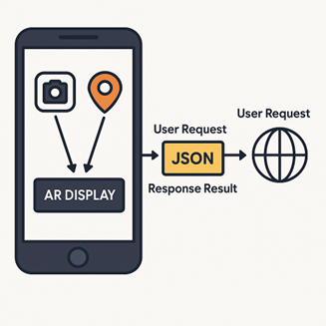

**Figure 1.** System architecture

* + 1. Development Process of AUMOR-AR

We used an incremental development model for mobile application development shown in Figure 2, which is an iterative approach that involves breaking down a project into smaller and manageable increments or iterations. Each iteration focuses on delivering a specific set of features or functionalities, allowing for continuous improvement and adaptation throughout the development process. The Begin outlines the overall goals and objectives of the mobile app. Identify the core features and functionalities that are essential for the initial release, as well as any additional features that can be added in future iterations. We then prioritized the features and functionalities based on their importance and impact on the app's success. Factors such as user needs, market demand, and technical complexity were considered when determining the priority of each feature. The first increment included the most critical features necessary to create a functional version of the app. This may involve basic functionalities such as user authentication, navigation, and core functionality. The features included in the first step were developed and tested. The focus was on creating a stable and reliable foundation for the app, ensuring that the core functionalities met the requirements and expectations of the users. Gather feedback from stakeholders, users, and usability testing sessions to evaluate the first increment of the system. This feedback was used to identify areas for improvement and prioritize changes for future iterations. The development process was iterated by adding new features and functions in subsequent increments. Each increment builds upon the previous one, gradually expanding the app's capabilities and addressing the user’s feedback and requirements. New features should be integrated into the app regularly, and updates should be deployed to users as soon as they are ready. This allows for the continuous delivery of value to users and enables rapid adaptation to changing market conditions and user requirements. The app's performance and user engagement metrics were monitored to identify opportunities for optimization and refinement. Analytics tools are used to track user behavior, identify usability issues, and make data-driven decisions for future iterations. As the app gains traction and user adoption increases, consider scaling up development efforts to add more advanced features and expand the app's functionality. Continue to prioritize features based on user feedback and market demand to ensure success. An ongoing feedback loop with stakeholders, users, and the development team was maintained throughout the incremental development process. Regularly solicit feedback, gather insights, and incorporate changes to ensure that the app evolves in alignment with users’ needs and expectations.

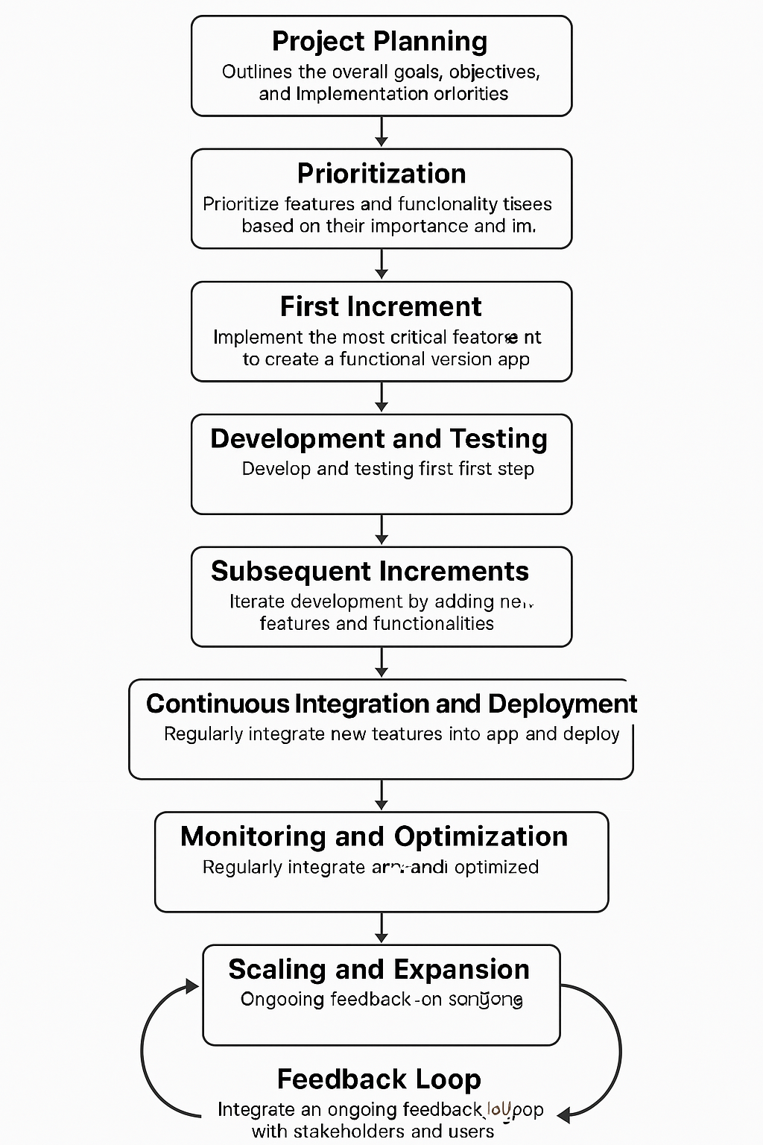

**Figure 2.** Incremental and iterative app development lifecycle

* + 1. User Interface Design and Navigation Flow

The user interface (UI) flow of the AUMOR-AR mobile application developed for university orientation is shown in Figure 3. The sequence begins with the app icon on the device home screen (first panel), providing quick access to the system. The second and third panels show the login screen, where users are required to input their email and password credentials. The log-in interface features a clean and minimalistic design, with a password visibility toggle, “forgot password” option, and sign-up prompt for new users. Once authenticated, users are directed to the main feature menu (fourth panel). This menu contains four core functionalities.

* GPS Guide – for navigation and location-based orientation on campus.
* QR Scanner – to retrieve contextual information and resources by scanning QR codes placed across the university facilities.
* Start Quiz: An interactive feature designed to reinforce orientation knowledge through gamified learning.
* Tutorial – offering guidance and instructions to new users, enhancing ease of use and adoption;

Together, these interfaces demonstrate the application’s student-centered design, emphasizing simplicity, accessibility, and the integration of location-based and interactive tools for effective student orientation.

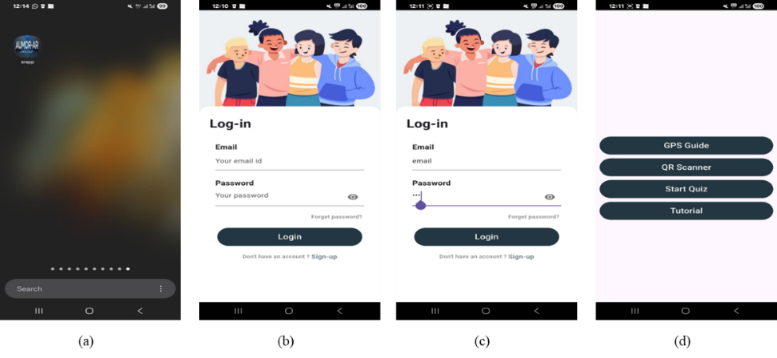

**Figure 3.** User interface flow of the AUMOR-AR application

* + 1. GPS Integration for Location-Based Services

The app uses GPS-based navigation to deliver information when a student nears a relevant place on campus. As they approach a building, service counter, or outdoor venue, the app activates an AR overlay that anchors to the scene and offers context-specific resources—short web links, quick videos, campus maps, downloadable PDFs, and, where appropriate, simple booking actions (e.g., study rooms or event check-ins). Pairing GPS with AR means that students see what matters for the spot they are standing in, reducing search time and helping first-time visitors move confidently between locations. To build this experience, we mapped key campus points of interest and recorded their precise coordinates using a campus base map (via Google Maps). Each location was added to a lightweight JSON catalog that stored its name, latitude/longitude, a geofence radius, and the set of AR assets to show on arrival as shown in Figure 4(a). On the app’s map view, this appears as a circle around each location (the geofence) and red markers for individual points—twenty-five in our pilot—so students can see what is nearby at a glance while content updates remain centrally managed.

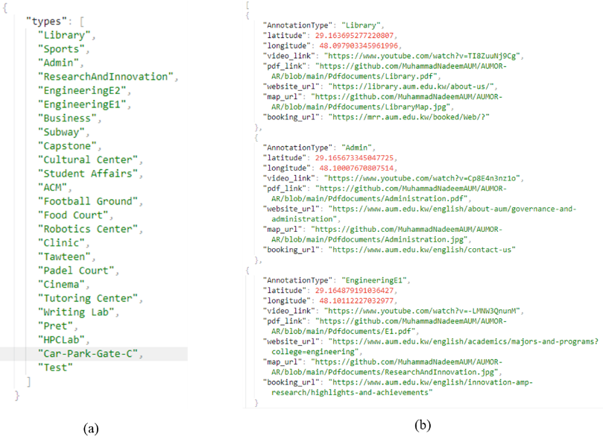

Figure 4. JSON data structure used for annotating campus locations and resources

When a student enters a geofence, the app displays the location name; tapping it opens an AR panel with the available options. A student nearing the Administration Building would see a prompt and upon clicking assets are streamed from the web to keep the app small, with essential items cached for spotty connectivity. The details of the metadata for selected annotations, including coordinates, video links, websites, booking links, and related documents is shown in Figure 4(b). This GPS-plus-AR approach turns the campus into an interactive guide, providing students with timely and trustworthy information as they navigate orientation.

Figure 5 illustrates the Augmented Reality (AR) navigation and information system of the AUMOR-AR application, designed to support students during university orientation. In the first panel shown in Figure 5(a), the system overlays a radar-style marker on the real-world environment to identify nearby locations such as laboratories, classrooms, study zones, cafés, and library rooms. Floating labels provide contextual information, including the name of the facility and its distance from the user, thereby enabling intuitive and location-aware navigation. In the second panel shown in Figure 5(b), multiple markers are displayed simultaneously, allowing users to view several facilities within the range, such as business buildings, computer labs, tutoring centers, and capstone project rooms. This functionality provides a comprehensive situational overview, reducing the cognitive load of navigation on large or unfamiliar campuses. The third panel in Figure 5(c) shows the interactive information panel triggered when a user selects a location. This panel provides access to rich multimedia and resources, including videos, documents, website links, room maps, and booking options. Such features extend the utility of AR beyond navigation, transforming it into an integrated learning and resource platform for orientation and daily campus use by students.

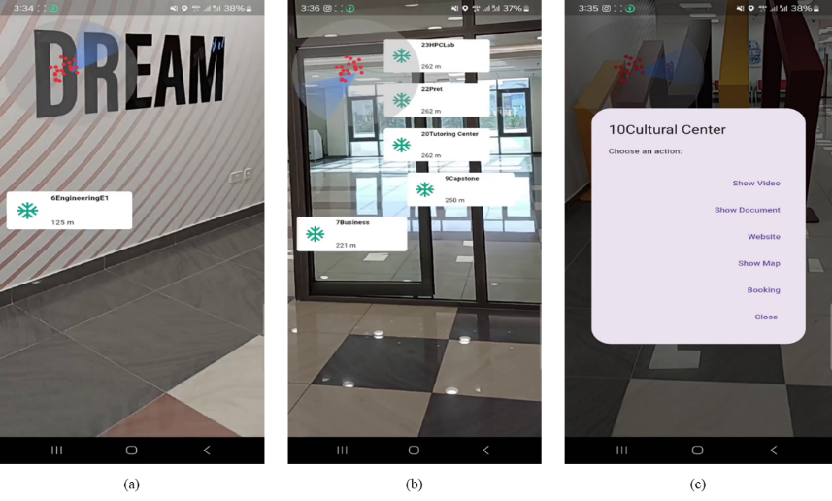

Figure 5. Augmented Reality navigation and resource interface of the AUMOR-AR application

* + 1. QR Code Implementation for Information Retrieval

For university orientation, we paired AR with QR codes placed at key locations (building entrances, labs, classrooms, offices, service counters, event booths, study spaces, parking, and prayer rooms). Each code encodes a short URL or ID that the app reads with the camera and resolves against a lightweight JSON catalog mapping that ID to an up-to-date content bundle (e.g., map route and floor plan, 30–120s video tour or safety clip, PDF guide or checklist, links to portals like advising/registration/menus/bus schedules/parking status, and contact details with office hours). On scan, the app presents these options as an AR overlay (and accessible list view); tapping opens the selected asset online, keeping the app small while allowing centralized updates without reprinting codes. This scan-to-experience flow delivers just-in-time information on where students stand, speeds wayfinding, and reduces friction for new users; success depends on clear, high-contrast code placement with labels (“Scan for office hours & directions”), reliable Wi-Fi or selective pre-caching of critical assets, and simple analytics to see which locations and resources are most used so content can be refined continuously.

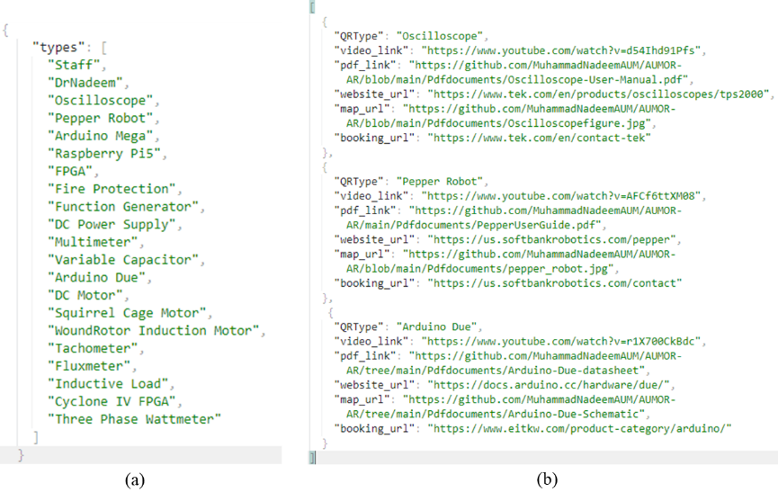

Figure 6. JSON data structure used for annotating laboratory resources embedded with QR code

Figure 7 demonstrates the application of a QR code–enabled information retrieval system designed to facilitate immediate access to technical documentation for the Arduino Due board. As shown on the left, the packaging integrates a QR code, thereby establishing a direct linkage between the physical hardware and relevant digital resources. Upon scanning the code, illustrated in the middle panel, the system recognizes the device as “Arduino Due” and presents users with a structured set of options, including video tutorials, datasheets, official website access, schematic drawings, and contact details. This functionality exemplifies how quick response (QR) technology can support efficient knowledge acquisition by minimizing the cognitive and temporal effort required to locate appropriate resources. The right panel illustrates the redirection to the official Arduino documentation portal, where authoritative materials such as pinout diagrams, datasheets, circuit schematics, and prototyping files are provided. Collectively, the workflow highlights the pedagogical and practical value of embedding QR codes into engineering education contexts, as it effectively bridges physical components with digital learning environments, promotes self-directed inquiry, and ensures learners’ engagement with current and reliable technical content.

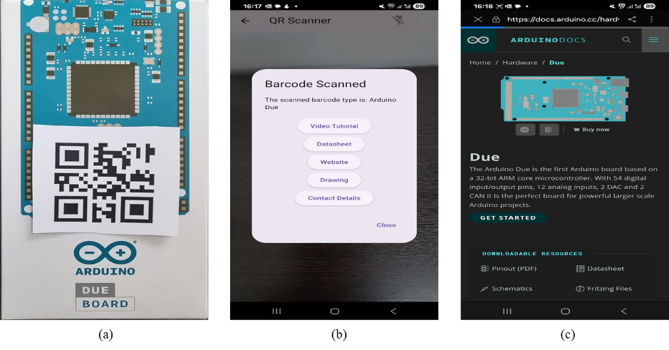

**Figure 7.** Workflow demonstrating QR code–based access to technical resources for the Arduino Due board.

1. **Result**

In this section, we present the evaluation results of our application. The data collected were analyzed using R software version 4.0.3. The internal consistency of the survey was very good, with Cronbach’s alpha of 0.927688. The overall Cronbach's alpha for this study was *α* = .928 (very good). Broken down by subscale, the internal reliability was *α* = .837 (good) for perceived usefulness, *α* = .734 (acceptable) for Perceived Ease of Use, *α* = .822 (good) for ATU, *α* = .828 (good) for BIU, and *α* = .521 (bad) for AU. The low value for AU is expected as the options provided for these questions are distinct features, not parallel items tapping one latent construct. The total number of participants was 128, comprising 39.84% males and 60.16% females, with their current academic levels reported in Table ***1***. Most participants were junior (36.72%) and sophomore students (31.25%).

**Table 1.** Participant demographics

|  |  |  |  |  |  |  |  |  |
| --- | --- | --- | --- | --- | --- | --- | --- | --- |
| Characteristics | Attributes | | | | | | | Total |
| Participant Gender | Male (51) | | | Female | | | | 128 |
| 39.84% (51) | | | 60.16% (77) | | | | 100% |
| Participant Age (Years) | Freshmen | Sophomore | Junior | | Senior | Faculty | Staff | 128 |
| 12.50% (16) | 31.25% (40) | 63.72% (47) | | 15.63% (20) | 3.13% (4) | 0.78% (1) | 100% |

Participants were generally comfortable with mobile apps, and a clear majority already used them for learning: approximately one-third (32.81%) reported using mobile applications for educational purposes often, and over a third (≈35%+) said they sometimes did so, meaning roughly seven in ten engaged in educational use at least intermittently. Only a small minority reported minimal engagement, with 4.69% using them rarely and 1.56% never using them for education. Taken together, these figures suggest strong readiness for app-based learning tools and imply that modest onboarding and targeted use cases could convert occasional users into more frequent users. Regarding familiarity with AR, most respondents (57.03%, 73) had not used an AR app before, while 40.63% (52) reported prior AR use; 2.34% (3) did not answer. This means that the campus AR app is new to many students, which helps explain the sizable neutral responses in ease-of-use/usefulness items—many are first-time users still forming opinions. Practically, this points to the value of lightweight onboarding (60–90-second tutorial, tooltips, “try this” tasks during orientation), clear terminology (e.g., anchoring, recentering), and performance polish to build early confidence. It also suggests analyzing outcomes by AR familiarity: prior users should, on average, report higher perceived ease and usefulness; if not, that signals usability gaps specific to the app rather than novelty effects.

The breakdown of perceived usefulness of the AR application is shown in Figure 8. The majority of the survey participants found the AR application useful in terms of understanding the university campus layout (60.16%), finding useful information about campus facilities (75%), and overall orientation experience (57.82%). For most of the participants (74.22%), using the AR app saved time in finding important campus locations, and it helped with confident campus navigation (57.03%).

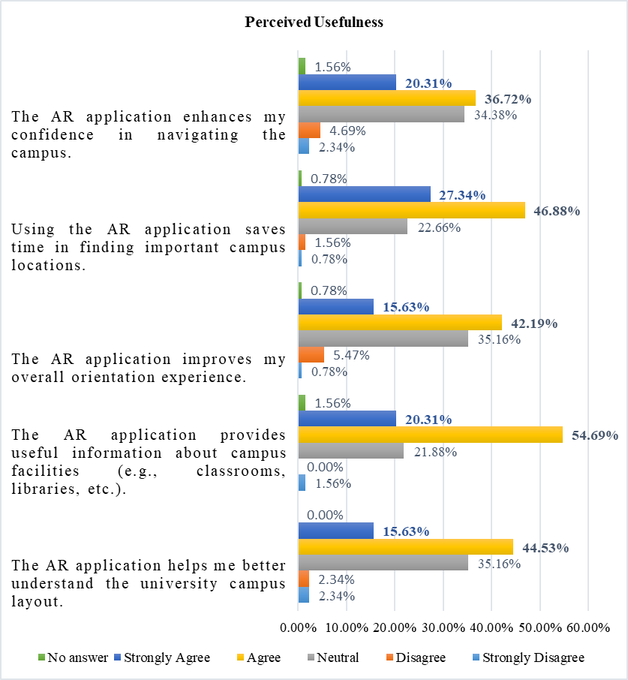

**Figure 8.** Breakdown of the perceived usefulness of the AR application.

Figure 9shows abreakdown of the perceived ease of use of the AR application. Most of the survey participants found information about different campus locations easily using the AR application (71.88%). They also found the AR app simple to learn and use (70.32%), and did not require additional instructions to understand how to use the application (49.22%). The AR app is quick in responding according to 54.68% of the survey participants, with a user-friendly layout and design (66.41%), and it is not difficult to use (52.35%).

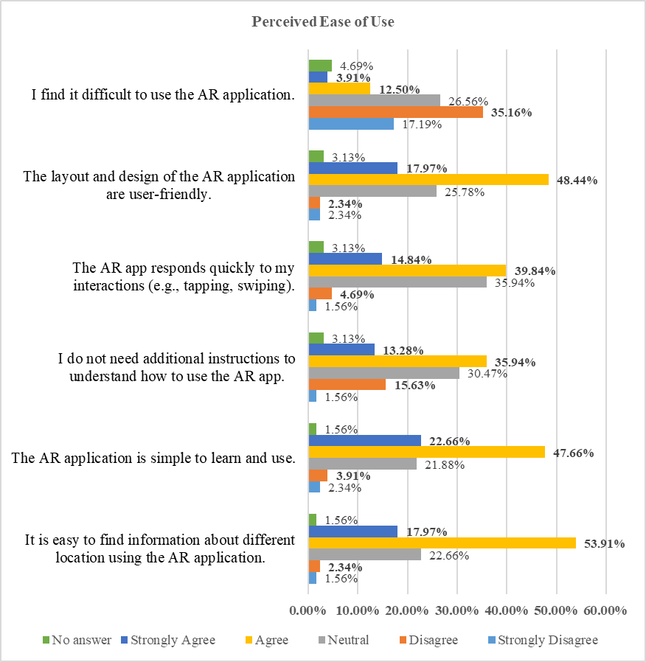

**Figure 9.** Breakdown of the perceived ease of use of AR application.

The ATU results were broadly positive, as shown in Figure 10. Students most strongly endorsed the concept, with 75.79% (47.66% agree, 28.13% Strongly Agree) believing that using the AR app for orientation was a good idea, with only 2.34% disagreeing and 18.75% neutral. They also find it engaging: 71.10% (46.88% + 24.22%) say the app is a fun way to explore the campus, while only 8.59% disagree and 17.19% are neutral. Personal experience was solid but mixed: 58.60% (40.63% + 17.97%) felt confident navigating with the app, while 30.47% were neutral and 7.04% disagreed. Similarly, 53.91% (37.50% + 16.41%) enjoyed using it during orientation, with a relatively high 35.94% neutral and 6.25% negative. Non-responses were small (3% for each item). In short, students buy into the idea and fun of AR, but a sizeable neutral bloc on confidence and enjoyment suggests room for onboarding and usability polish (quick tips, clearer labels, performance smoothness) to convert the undecided into enthusiastic users.

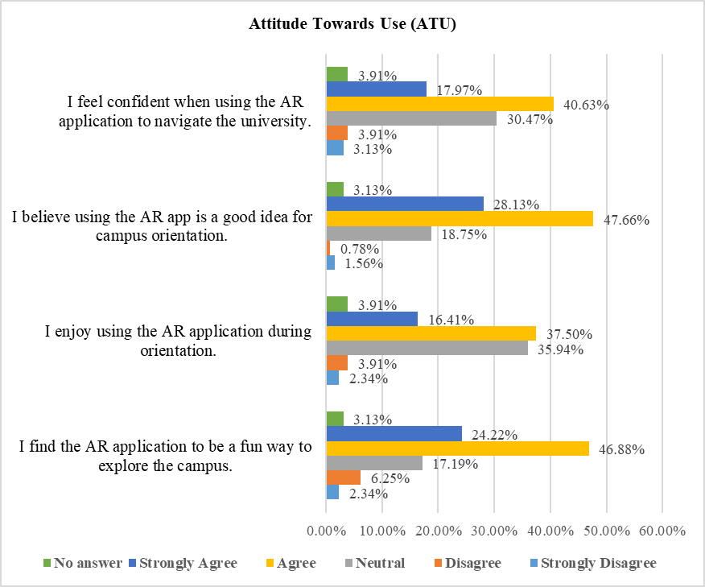

**Figure 10.** Breakdown of attitude towards the use of the AR application.

The Behavioral Intention to Use (BIU) results shown in Figure 11are strong overall as 75.0% would recommend the AR app to other students (42.19% Agree, 32.81% Strongly Agree), with only 7.03% negative and 14.84% neutral. Preference for traditional orientation methods is positive but more mixed: 53.9% favor the AR approach (33.59% agree, 20.31% Strongly Agree), while 29.69% are neutral and 11.72% disagree—suggesting many are open to AR but still comparing it with familiar formats. The intent to continue using the app during university was similarly moderate: 52.35% positive (35.94% agree, 16.41% Strongly Agree), 32.81% neutral, and 10.16% negative.

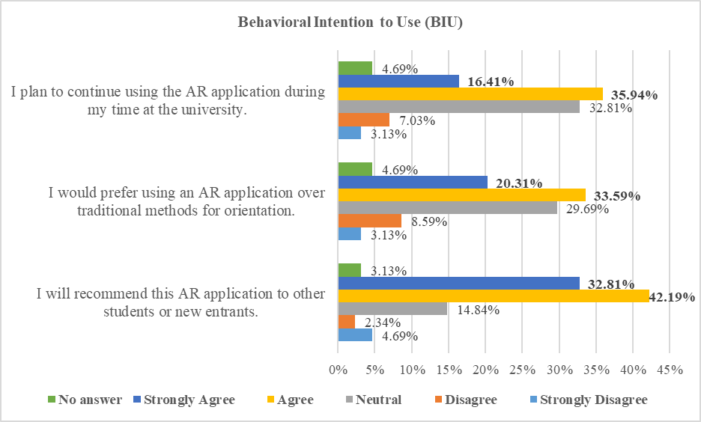

**Figure 11.** Breakdown of the behavioral intention to use the AR application.

* 1. **Actual Use (AU)**

The breakdown of the usage of the different features of the AR application is shown in *Figure 12*. We observed that the survey participants used the AR app mainly for campus navigation (51.56%) and for finding information about lab equipment (39.06%). Approximately one-third of the participants used the AR app to find specific buildings or departments (29.69%), gather information on student services (28.91%), and access event schedules (27.34%). Some participants were also interested in virtual campus tours (18.75%).

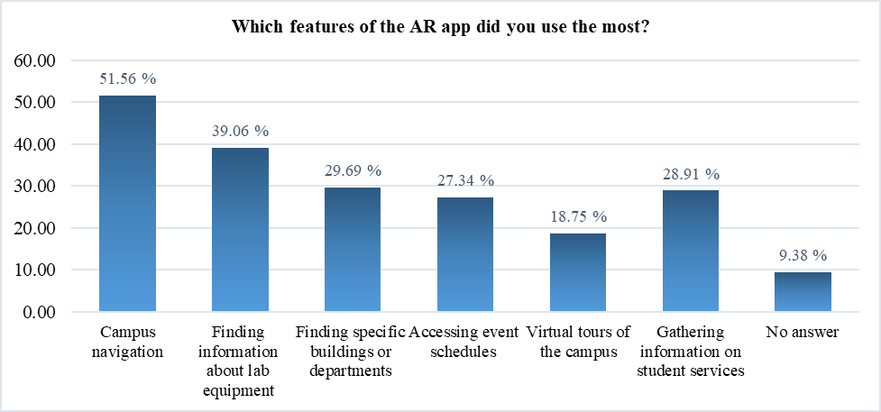

**Figure 12.** Breakdown of the usage of the different features of the AR application.

Figure 13shows the frequency of AR application usage during orientation. We can observe that 34.38% of the survey participants used the AR application during their orientation a few times, 17.19% of them used the AR app regularly throughout the orientation, while 10.94% used it only once.

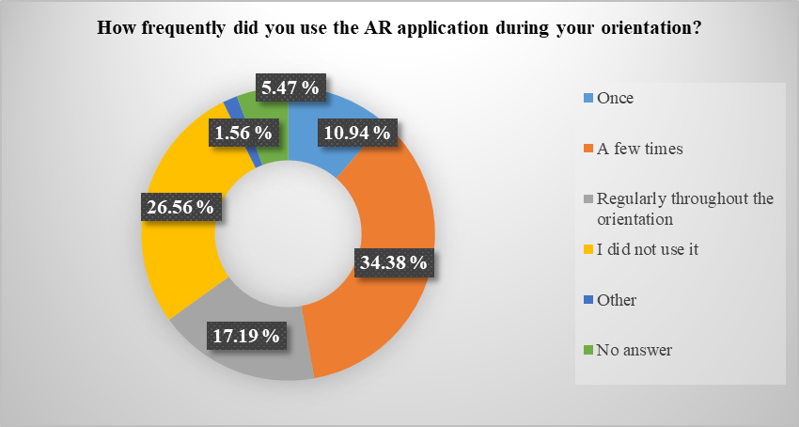

**Figure 13.** Frequency of AR application usage during orientation.

Figure 14shows the intended use of the AR application after the orientation. Most of the survey participants were likely or very likely to continue using the AR application after the orientation (57.03%).

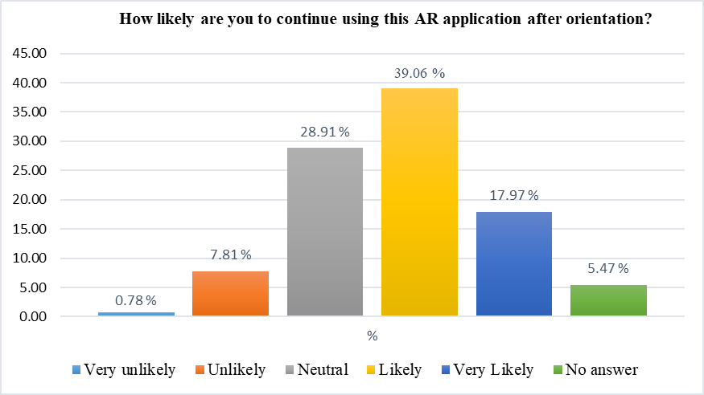

**Figure 14.** Intended usage of the AR application after the orientation

We performed an inductive thematic analysis to the open-ended item “What kind of information would you like to see on the application?” The responses were multi-coded, so totals can exceed 100% and outcomes are.

* Real-time status / availability
* Events & schedules (with reminders)
* Academic info and student services
* Navigation and wayfinding
* Booking of utilities
* Onboarding/help & usability

We also performed an inductive thematic analysis to the second open-ended item “What will you suggest improving this application?” The responses were multi-coded, so totals can exceed 100% and outcomes are provided in **Error! Reference source not found.**.

* iOS availability / distribution
* Performance, reliability & accuracy
* UI/UX simplification & modernization
* Live status features
* Content expansions (services & hours)

1. **Discussion**
   1. *Interpretation of Evaluation Results*

The evaluation results of AUMOR-AR confirmed the potential of augmented reality combined with GPS and QR code technologies to improve the orientation experience of new students. The highest ratings were for perceived usefulness in terms of time-saving and facility information (~74–75%), reflecting the app’s success in addressing immediate student needs for quick access to contextual information. This aligns with prior research indicating that mobile applications are particularly valued when they reduce effort and provide convenience in real-world tasks. However, ratings for confidence in navigation (~57%) and improvement in overall orientation experience (~58%) were more moderate, suggesting that the app currently functions more as an information delivery tool than as a complete wayfinding solution.

The ease of use results were similarly promising, with a majority of participants finding the application simple to learn (approximately 70%), intuitive for accessing campus-related information (around 72%), and user-friendly in its layout (roughly 66%). These findings align with the core tenets of the Technology Acceptance Model (TAM), which emphasizes *perceived ease of use* as a critical factor influencing user acceptance and sustained engagement with technology (Davis, 1989). Numerous studies have reaffirmed that ease of use significantly predicts behavioral intention and actual usage, especially in educational technology contexts (Putri et al., 2025; Mercer & La Marca, 2024). Specifically, in AR-based learning environments, students who perceive systems as easier to navigate are more likely to develop positive attitudes and trust in the system (Putri et al., 2025). However, the relatively weaker scores in system responsiveness and the expressed need for onboarding support suggest areas for enhancement. These concerns are consistent with findings that underscore the importance of *system responsiveness and structured onboarding* in AR applications to reduce cognitive load and anxiety (Bello & Abdurrahman, 2025; Idkhan et al., 2025). Given that many students may be unfamiliar with AR technologies, the integration of short guided tutorials and improved system responsiveness could substantially enhance user confidence and overall adoption. Prior research indicates that structured support materials and smooth interface feedback loops act as critical enablers in bridging initial resistance and improving perceived ease of use (Buchem et al., 2025; Gong et al., 2025).

The results regarding attitude towards use show strong endorsement of AUMOR-AR as a valuable and engaging tool for university orientation. Nearly three-quarters of respondents (≈76%) agreed or strongly agreed that using the AR app was a good idea for orientation, and over 70% found it a fun way to explore the campus. These findings highlight that students view AR not only as functional but also as enjoyable, supporting the premise that perceived enjoyment can reinforce acceptance, as noted in the extended versions of the Technology Acceptance Model 3 (TAM3). However, indicators of confidence and personal enjoyment during orientation were somewhat lower (≈54–59%), with a sizable proportion of neutral responses (≈30–36%). This suggests that while the concept of AR is broadly attractive, some students remain cautious or undecided about its reliability and personal value for practical use. Such hesitation is often linked to first-time exposure to AR technologies, as many participants (57%) had never used AR. Practical strategies to improve confidence could include micro-onboarding (short tutorials, tooltips, or guided “first use” experiences), performance optimization to reduce lag, and improved indoor navigation accuracy. These measures can convert neutral attitudes into more enthusiastic adoption, maximizing impact of AUMOR-AR.

The behavioral intention outcomes were similarly promising. Most students (75%) reported a willingness to recommend the AR app to peers, demonstrating strong word-of-mouth potential. Over half expressed a preference for AR-based orientation over traditional methods (~54%) and indicated plans to continue using the app during their studies (~52%). These results suggest that AUMOR-AR has a clear pathway toward sustained adoption, provided that its reliability and relevance continue to improve. Nonetheless, the relatively large neutral segments (≈30%) for both preference and continued use point to the need for deeper integration of the app into students’ daily academic lives. Features such as real-time event reminders, schedule-linked routing to classrooms, live updates on facilities, and academic service integration (grades, office hours) could embed the app into routine student practice. Aligning AR content with students’ immediate academic and administrative needs may transform the app from a one-time orientation aid into a long-term companion throughout their university journey. In line with the TAM, the BIU findings underscore that positive attitudes and perceived usefulness drive the intention to use. By capitalizing on high recommendation rates and strategically addressing areas of hesitation, universities can ensure that AR orientation apps such as AUMOR-AR become an integral part of the student experience rather than a novelty used only at the start of the academic year.

The analysis of student feedback highlights six major domains of desired mobile application features for enhancing the campus experience. Real-time status and availability information was frequently emphasized (~25–30%), with students requesting live updates on parking occupancy, building or café crowding, event changes, and utilities such as power or air conditioning status. Such features reflect the increasing demand for context-aware smart campus systems that improve mobility and decision-making in real time (Alsaeedi & Al-Sarem, 2021).

*“Available parking; if the building is crowded or not”; “real time bus schedules and cafeteria menus”; “real time updates about campus events.”*

Events and schedules were also a high priority (~20–25%), with students requesting centralized access to event dates, semester-specific schedules, and integrated reminder functions, aligning with prior findings that calendar-linked notifications significantly improve student engagement (Aljohani, 2019).

*“Events (date, when?)”; “event schedules for all majors”; “events table”; “reminders”*

The largest category (~30–35%) was academic information and student services, including grades, GPA tracking, assessment feedback, project updates, and faculty office hours. This resonates with previous research indicating that academic transparency and immediate access to assessment data strongly influence student satisfaction with learning technologies (Davis et al., 2022).

*“Maybe if it could show the students’ grade in each assessment”; “What GPA I have”; “office hours of faculty… course projects”*

Navigation and wayfinding was another prominent need (~25–30%), where students envisioned location-aware routing linked directly to their class schedules, echoing evidence that location-based services improve campus accessibility and efficiency (Shen et al., 2018).

*“Campus navigation”; “when I click on my class it shows me the way”; “places of every building”*

Meanwhile, booking and utilities (~5–10%) focused on study room reservations and workshop/lab bookings, functions increasingly integrated into smart campus platforms (Caviglione et al., 2020).

*“Book spots/rooms for studying”; “booking workshop like robotics”*

Finally, onboarding, help, and usability (~10–15%) were cited, including requests for clearer information, full campus guides, and FAQ sections, particularly valuable for first-year students adapting to a new academic environment (Henderson et al., 2017).

*“More clear information”; “A full guide… with feedback”; “a FAQ section for new students”*

Collectively, these findings indicate that students prioritize functionality that reduces uncertainty, supports academic progress, and personalizes campus engagement, reinforcing the growing role of mobile and smart technologies in shaping higher education experiences.

Student feedback on desired improvements to the campus mobile application emphasizes six key domains of functionality. iOS availability and distribution emerged as the most frequently mentioned (~30–40%), with students requesting that the app be made accessible via the Apple App Store to support iPhone users. This aligns with broader evidence showing that cross-platform compatibility significantly increases adoption and inclusivity in higher education mobile applications (Mtebe & Raisamo, 2014).

*“Upload it in the Apple…”, “make it for iOS”, “allow iPhone users to download it”*

Performance, reliability, and accuracy (~25–30%) were also highlighted, with students demanding faster load times, bug fixes, and more precise location and AR features. Prior studies have similarly shown that system responsiveness and reliability are critical determinants of user satisfaction and continued use in educational apps (Sarrab et al., 2015).

*Faster response… quicker updates”, “more precise locations”, “fix bugs”*

Another prominent theme was UI/UX simplification and modernization (~20–25%), where students requested clearer layouts, organized lists, and more interactive designs. Research on learning technologies confirms that well-structured and aesthetically modernized interfaces reduce cognitive load and increase user engagement (Nouri, 2018).

*“Make the layout clearer”, “organize everything in lists”, “update the app design”*

Students also requested notifications and reminders (~10–15%), including alerts for schedules, assignments, and events, reflecting earlier findings that push notifications and reminders enhance time management and academic performance (Aljohani, 2019).

*“Alerts that remind you about schedule”, “assignment reminders”*

Finally, content expansions (~15–20%) were noted, with calls for more comprehensive coverage of office locations, hours, semester dates, and class times. Such expansions align with research showing that information-rich applications increase perceived usefulness and institutional trust (Henderson et al., 2017).

*“office hours and office place”, “updated semester schedule”*

Collectively, these insights suggest that students prioritize inclusivity, reliability, modern design, and real-time support as essential to the effectiveness of smart campus mobile applications.

* 1. *Strengths and Weaknesses of AUMOR-AR*

AUMOR-AR’s main strengths lie in the integration of GPS and QR code scanning with AR overlays, which provides students with contextualized, real-time information. This design was appreciated for its ability to reduce the time spent searching for facilities and resources, aligning well with the goals of orientation programs. Its incremental development model also allows for iterative improvement and scalability.

However, some weaknesses were evident. Senior students, who were already familiar with the campus, found limited added value in basic navigation and facility information. Moreover, performance limitations, such as lag in AR responsiveness and occasional imprecision in location detection, reduced user confidence. Accessibility gaps were also highlighted, especially the lack of iOS compatibility, which was one of the most common suggestions for improvement. These weaknesses echo the findings from previous AR campus systems, which frequently encountered barriers related to technical stability, inclusivity, and scalability.

* 1. *Comparison with Previous Studies*

Compared with earlier AR-based orientation initiatives, AUMOR-AR offers several advancements. Early systems, such as those at Columbia University and Fu-Jen Catholic University, focused on head-mounted displays or AR visualization of campus landmarks; however, they often required specialized hardware and offered limited scalability. More recent efforts at Chung Hua University and the University of Quindío integrated multimedia and 3D directional boards; however, they lacked GPS precision or QR code versatility. In contrast, AUMOR-AR’s hybrid approach, which leverages widely available smartphone hardware with both GPS-based geofencing and QR-triggered AR overlays, achieves broader accessibility and reduces reliance on costly infrastructure.

Furthermore, AUMOR-AR’s evaluation of over 120 participants adds to the literature by providing a large-scale empirical dataset. While studies at universities such as Bowling Green State or Haaga-Helia UAS focused on niche features (cultural exploration or missed orientation catch-up), AUMOR-AR demonstrates the feasibility of embedding AR into mainstream orientation practices. Its integration of TAM as an evaluative framework also provides a theoretical contribution, bridging technology adoption theory with situated learning perspectives in the university orientation context.

* 1. *Implications for University Orientation Practices*

The implications of this study for practice are significant. First, AUMOR demonstrates that mobile AR can complement or partially substitute for traditional orientation programs, which are resource-intensive and costly. By embedding real-time information at physical locations through QR codes and GPS triggers, the app promotes situated learning, enabling students to learn by doing within authentic campus contexts. Second, the open-ended feedback from students underscores the demand for richer real-time functionality, including live updates on parking, event schedules, and crowding, as well as integration with academic services. Incorporating these features would extend the utility of AR beyond orientation into everyday student life and foster long-term engagement. Finally, the results reinforce that technology adoption hinges not only on novelty but also on reliability, inclusivity and relevance. Addressing performance stability, expanding platform availability, and layering personalized academic content are essential steps for maximizing impact. In the broader landscape of AR orientation research, AUMOR represents a meaningful step forward by combining affordability, accessibility, and empirical validation, thus offering a model for institutions seeking to modernize orientation practices.

* 1. *Alignment with Sustainable Development Goals*

Beyond its immediate contributions to orientation, AUMOR aligns with the United Nations Sustainable Development Goals (SDGs). By enhancing access to information and improving the quality of student transition experiences, the app supports SDG 4 (Quality Education), which emphasizes inclusive and equitable access to lifelong learning. The system also reflects SDG 9 (Industry, Innovation, and Infrastructure) as it leverages cutting-edge mobile and AR technologies to build scalable digital infrastructure for higher education. Moreover, by reducing reliance on resource-intensive traditional orientation events, AUMOR-AR indirectly contributes to SDG 12 (Responsible Consumption and Production) by lowering costs and minimizing environmental impacts. Thus, the project not only addresses the local challenge of student orientation but also contributes to global priorities for sustainable, technology-enabled education.

1. **Conclusion**

This study presents the design, implementation, and evaluation of the AUMOR-AR application, a personalized mobile tool developed to support student orientation and navigation within a university campus. By integrating augmented reality, GPS, and QR code technologies, the application demonstrated its potential to address a persistent challenge faced by students: feeling disoriented, overwhelmed, and time-pressed in large and complex academic environments. The evaluation results indicated that students found the system useful for saving time and accessing facility information, and the clean design and simple interface contributed to perceptions of ease of use. Furthermore, the incorporation of interactive features, such as floating labels, multimedia resources, and quizzes, highlights the versatility of AR not only as a navigation aid but also as a tool for engagement and learning. Research on GPS and QR code-based AR applications for university orientation advances educational technology knowledge. Researchers can explore innovative approaches to enhance student orientation experiences and contribute to literature on immersive learning environments. Student services offices can leverage these findings by integrating AR applications into orientation activities, providing interactive experiences that promote engagement. AR applications create engaging learning experiences that appeal to digitally savvy students. Despite its promise, the study also revealed areas for improvement, including the need for performance optimization, cross-platform availability, and enhanced personalization of the model. These findings underscore that technology adoption is shaped not only by novelty, but also by reliability, inclusivity, and relevance to students’ daily needs. Compared with previous AR-based orientation systems, AUMOR advances the field by combining affordability, scalability, and empirical validation within a real-world context. Looking ahead, future work should focus on refining the application for broader deployment and expanding its features to include live event updates, academic service integration, and accessibility options to support diverse student populations. Thus, AUMOR can evolve into a comprehensive digital campus companion that contributes to improved student experience, time management, and well-being.

**Supplementary Materials:** The following supporting information can be downloaded at: https://www.mdpi.com/article/doi/s1, Figure S1: title; Table S1: title; Video S1: title.

**Author Contributions:** For research articles with several authors, a short paragraph specifying their individual contributions must be provided. The following statements should be used “Conceptualization, X.X. and Y.Y.; methodology, X.X.; software, X.X.; validation, X.X., Y.Y. and Z.Z.; formal analysis, X.X.; investigation, X.X.; resources, X.X.; data curation, X.X.; writing—original draft preparation, X.X.; writing—review and editing, X.X.; visualization, X.X.; supervision, X.X.; project administration, X.X.; funding acquisition, Y.Y. All authors have read and agreed to the published version of the manuscript.” Please turn to the [CRediT taxonomy](https://img.mdpi.org/data/contributor-role-instruction.pdf) for the term explanation. Authorship must be limited to those who have contributed substantially to the work reported.

**Funding:** Please add: “This research received no external funding”

**Data Availability Statement:** We encourage all authors of articles published in MDPI journals to share their research data.

**Acknowledgments:** In this section, you can acknowledge any support given which is not covered by the author contribution or funding sections. This may include administrative and technical support, or donations in kind (e.g., materials used for experiments). Where GenAI has been used for purposes such as generating text, data, or graphics, or for study design, data collection, analysis, or interpretation of data, please add “During the preparation of this manuscript/study, the author(s) used [tool name, version information] for the purposes of [description of use]. The authors have reviewed and edited the output and take full responsibility for the content of this publication.”

**Conflicts of Interest:** The authors declare no conflicts of interest.”

Abbreviations

The following abbreviations are used in this manuscript:

|  |  |
| --- | --- |
| MDPI | Multidisciplinary Digital Publishing Institute |
| DOAJ | Directory of open access journals |
| TLA | Three letter acronym |
| LD | Linear dichroism |

Appendix A

Appendix A.1

**Table A1.** This is a table caption.

|  |  |  |
| --- | --- | --- |
| **Title 1** | **Title 2** | **Title 3** |
| entry 1 | data | data |
| entry 2 | data | data |

Appendix B

All appendix sections must be cited in the main text. In the appendices, Figures, Tables, etc. should be labeled starting with “A”—e.g., Figure A1, Figure A2, etc.

References

1. Author 1, A.B.; Author 2, C.D. Title of the article. *Abbreviated Journal Name* **Year**, *Volume*, page range.
2. Author 1, A.; Author 2, B. Title of the chapter. In *Book Title*, 2nd ed.; Editor 1, A., Editor 2, B., Eds.; Publisher: Publisher Location, Country, 2007; Volume 3, pp. 154–196.
3. Author 1, A.; Author 2, B. *Book Title*, 3rd ed.; Publisher: Publisher Location, Country, 2008; pp. 154–196.
4. Author 1, A.B.; Author 2, C. Title of Unpublished Work. *Abbreviated Journal Name* year, *phrase indicating stage of publication (submitted; accepted; in press)*.
5. Author 1, A.B. (University, City, State, Country); Author 2, C. (Institute, City, State, Country). Personal communication, 2012.
6. Author 1, A.B.; Author 2, C.D.; Author 3, E.F. Title of Presentation. In Proceedings of the Name of the Conference, Location of Conference, Country, Date of Conference (Day Month Year).
7. Author 1, A.B. Title of Thesis. Level of Thesis, Degree-Granting University, Location of University, Date of Completion.
8. Title of Site. Available online: URL (accessed on Day Month Year).

**Disclaimer/Publisher’s Note:** The statements, opinions and data contained in all publications are solely those of the individual author(s) and contributor(s) and not of MDPI and/or the editor(s). MDPI and/or the editor(s) disclaim responsibility for any injury to people or property resulting from any ideas, methods, instructions or products referred to in the content.